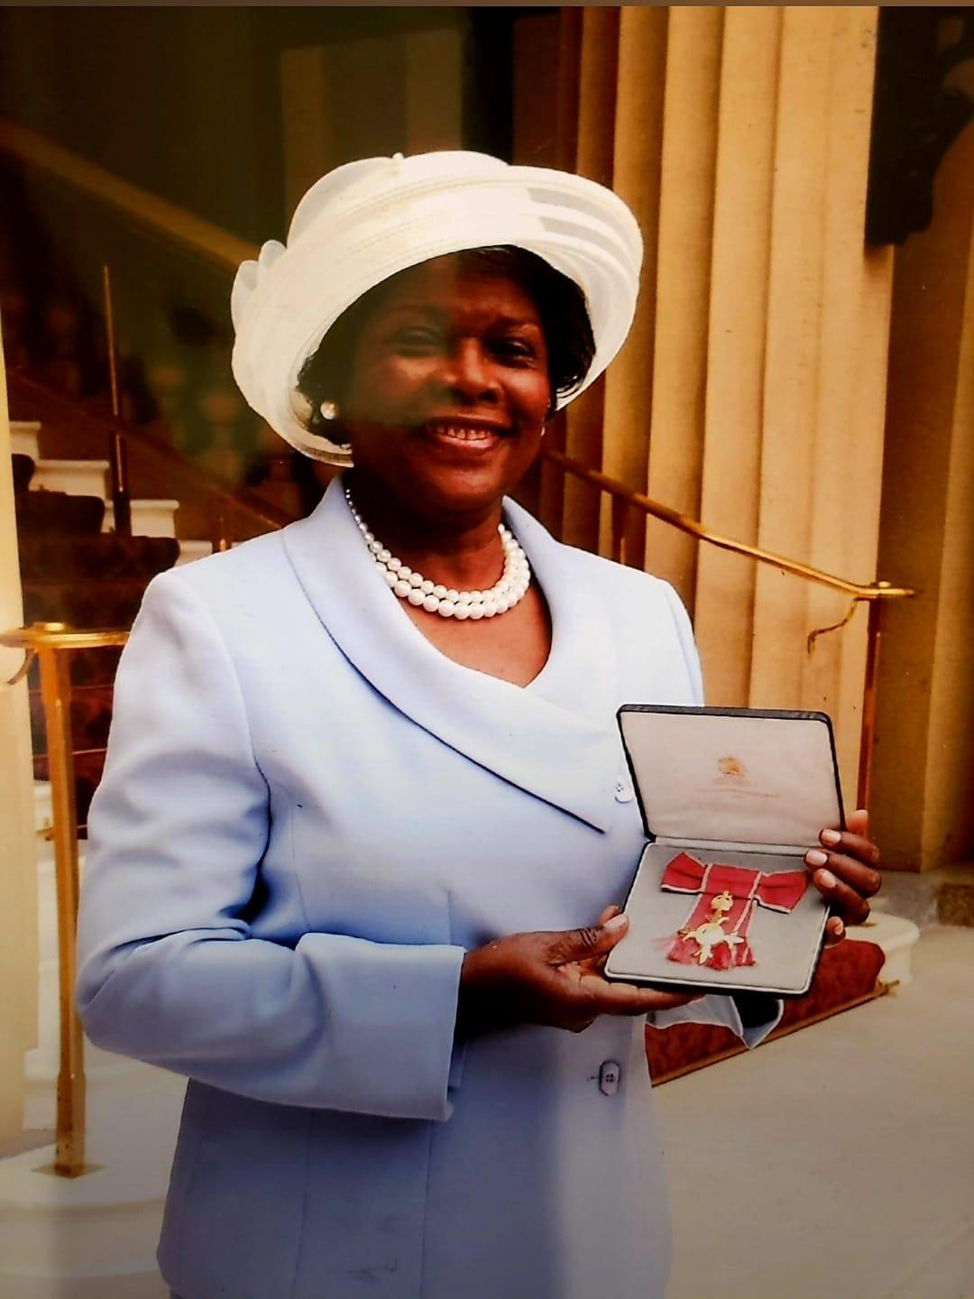

**Mrs. Dulcie Richardson** was the first Principal of the College of Further Education which was established in September 1988, with the amalgamation of four (4) existing institutions: The Teachers’ College, The Technical College, The Sixth Form, and The School of Nursing. Adult and Continuing Education came at a later date. With a mandate from the Ministry of Education, Mrs. Richardson was instrumental in the planning stages of the College with the guidance of the UWI School of Education, Cave Hill Campus.

During the planning stages for tertiary level education, the names of the four institutions were changed in keeping with the purposes envisaged. The Teachers’ College became The Division of Teacher Education, the Technical College was called the Division of Technical and Vocational Education and Management Studies, The School of Nursing was named The Division of Health Sciences, and The Sixth Form was changed to The Division of Arts, Science and General Studies.

At that time the Divisions remained where they were initially, because there was not yet a building available to accommodate the entire College. The Heads of Division met periodically with the Principal in a renovated, temporary building which was on the present compound of the College to discuss matters pertaining to the progress of the new institution.

Before Mrs. Richardson was appointed Principal of the College of Further Education, she was Principal of the Teachers’ College for a period of approximately sixteen years. She retired from the Public Service in 1990, two years after the establishment of the College of Further Education, now renamed the Clarence Fitzroy Bryant College (CFBC).

Mrs. Richardson was honoured by Queen Elizabeth 11 in 2002 with the award of Officer of the British Empire (OBE) medal for Community Service and Education.